**Experiment No: 11**

**Name of the Experiment:** Study Of Lagrange Interpolation Method To Predict The Unknown Value(s) For Any Geographic Point Data.

**Objectives:** The objective of this experiment is to apply Lagrange interpolation method to find out the unknown value(s) for a specific values(s) from a data table.

**Theory:** The Lagrange interpolating polynomial is the [polynomial](http://mathworld.wolfram.com/Polynomial.html) P(x)of degree <=(n-1)that passes through the npoints (x_1,y_1=f(x_1)), (x_2,y_2=f(x_2)), ..., (x_n,y_n=f(x_n)), and is given by [1]

|  |  |  |
| --- | --- | --- |
| P(x)=sum_(j=1)^nP_j(x), |  | (1) |

where

|  |  |
| --- | --- |
| P_j(x)=y_jproduct_(k=1; k!=j)^n(x-x_k)/(x_j-x_k). | (2) |

Written explicitly,

|  |  |  |
| --- | --- | --- |
| P(x) | = | ((x-x_2)(x-x_3)...(x-x_n))/((x_1-x_2)(x_1-x_3)...(x_1-x_n))y_1+((x-x_1)(x-x_3)...(x-x_n))/((x_2-x_1)(x_2-x_3)...(x_2-x_n))y_2+...+((x-x_1)(x-x_2)...(x-x_(n-1)))/((x_n-x_1)(x_n-x_2)...(x_n-x_(n-1)))y_n. |

**Tool:** MATLAB Software

**Methodology:**

**MATLAB Code:**

x = [1.5 3 6];

y = [-.25 2 20];

n = size(x, 2);

%value for fining fx

x\_int = 4;

%% determining sum by formula

y\_int = 0;

for i = 1:n

p = y(i);

for j = 1:n

if i ~= j

p = p \* ((x\_int - x(j)) / (x(i) - x(j)));

end

end

y\_int = y\_int + p;

end

y\_int

%% ploting the graph

plot(x, y, 'bo', x\_int, y\_int, 'ro')

axis([1 20 -.1 30])

xlabel('x')

ylabel('y')

**Output:**

**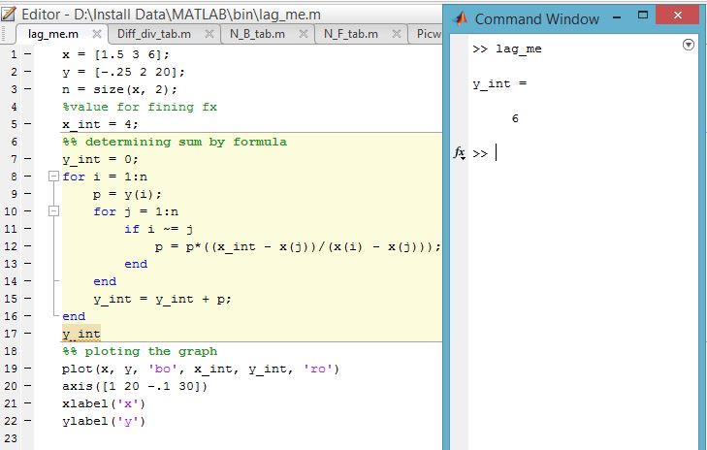**

**---------------------------------------------------------**

**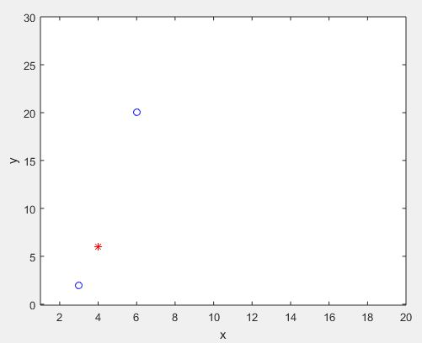**

**Figure 11.1: Graph Of The Function**

**Result(s)& Discussion:** The unknown value for x = 4 is y = 6.From text book for x=4 is y=5.99 ~ 6

**Conclusion:** We have found the exact unknown value for 4 which is same as text book. MATLAB read 5.999 to round figure value 6.

**References:**

[1]C. Chapra and P. Canale Raymond , “*Numerical Methods for Engineers”,* 7th ed. McGraw-Hill Education, 2 Penn Plaza, New York, NY 10121, 2015